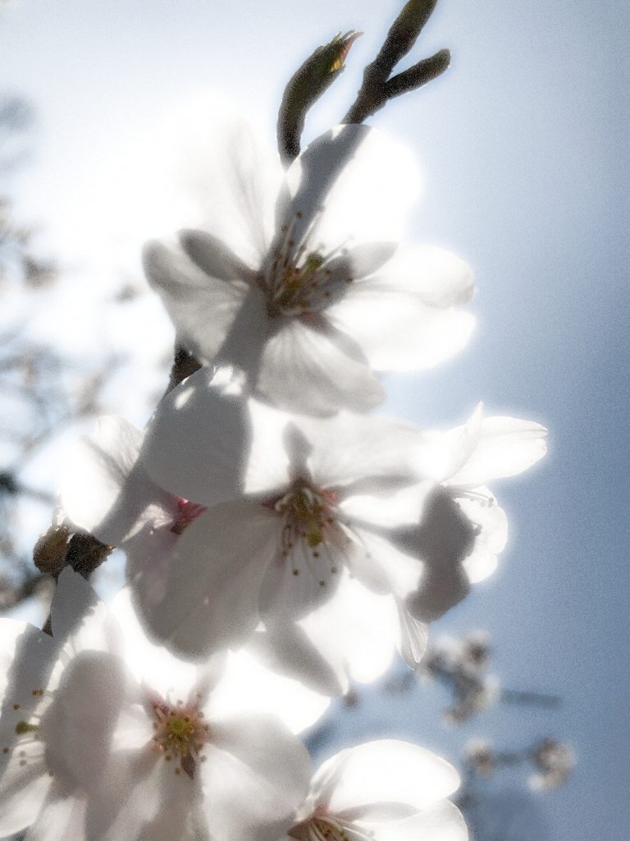

21st
Okayama
Linguistics Forum
Speaker: Hidekazu Tanaka (Okayama University)

Talk Title: “Case-Particles and Quantifier Scope”

Abstract:
“The talk focuses on the interaction of quantificational expressions, negation, and Case-particles in Japanese. Under certain conditions, quantifiers with a Case-particle display wider scope possibilities than those without. The observation is examined in terms of the current development of the minimalist program.”

Date & Time: 25th April, 2024, 16:30-18:00
Venue: T-53 (Trinity Hall 5F, 正門からお入り下さい)
Notre Dame Seishin University

_{Zoomでのhybrid開催}
初めて参加される方は、お名前と所属先を明記して4月21日(日)までに木津(mikakizu@m.ndsu.ac.jp)へご連絡ください。

